Name: ______________________________ School: ________________________________

Chapter 1, Problem Set 1:
Refer to lecture notes for Chapter 1 on Vectors, Libraries and Plasmid DNA Preps on the WSSP web site for background information.

1. What are vectors used for?

2. What is a selectable marker and what is it used for on the plasmid?

3. What is a polylinker and what is it used for on the plasmid?

4. Why are we doing minipreps?

5. Refer to the MiniPrep Protocol in Lab 4-1 for the following question. In preparing double-stranded plasmid DNA preps there are a lot of separation steps that involve the microcentrifuge. After each step you must keep one portion and discard the other. Circle the portion (Supernatant, pellet, column, or flow through) that you want to keep after centrifugation at each of the following steps:

a) The centrifugation of the bacterial culture.

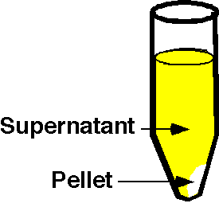
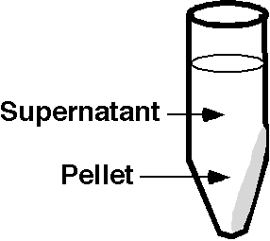
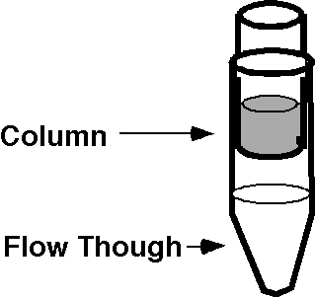

b) The centrifugation after adding Solution III.

c) The centrifugation after loading your DNA onto the Spin column.

d) The centrifugation after adding Wash buffer to the Spin column.

e) The centrifugation to dry the Spin column.

f) The centrifugation after adding water to the Spin column.

