Chapter 1
Vectors and Libraries

Information in this lecture was adopted from Chapter 7 in “Introduction to Genetic Engineering” by W. H. Sofer, Butterworth-Heinemann Publishing; “An Introduction to Recombinant DNA Techniques” by P.B. Hackett, J.A. Fuchs, and J.W. Messing, Benjamin/Cummings Publishing Co., Inc. The plasmid miniprep procedure is based on the one developed by GE Healthcare. Some of the figures are from the Catalogs of New BioLabs and Clontech Inc.

1. Introduction
In order to study a DNA fragment (e.g., a gene), it needs to be stored, amplified and eventually purified. These tasks are accomplished by cloning the DNA fragment into a vector. A vector is often a small, circular DNA molecule, called a plasmid, that replicates inside a bacterium such as Escherichia coli. DNA fragments of interest are inserted (cloned) into the vector by digesting the vector DNA with restriction endonuclease enzymes that cleave at specific positions (A and B in the figure) and pasting (ligating) the fragment of interest into the vector (Fig 1-1). The clone (vector + insert) DNA is then introduced (transformed) back into bacteria where it can replicate. Thus, as the vector replicates, so does the cloned DNA fragment. The vector therefore acts as a carrier, which allows one to isolate and amplify a DNA fragment of interest.
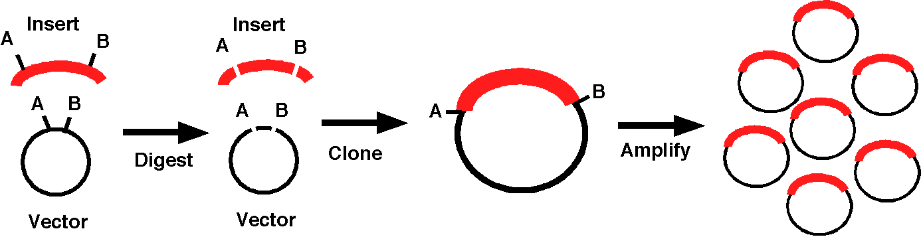
Fig 1-1. Cloning an insert DNA fragment (red) into a vector allows the isolation of a large quantity of the fragment.

2. Plasmids
a. Plasmids are circular DNA molecules found in bacteria that are replicated by the host’s machinery independently of the genome. This is accomplished by a sequence on the plasmid called ori, for origin of replication. Specifically, the host’s replication proteins recognize and bind to the ori, initiating replication of the entire plasmid. Some plasmids are present in E. coli at 200-500 copies per cell, while others are present in only 1-2 copies.

b. In addition to containing an ori sequence, plasmids also contain selectable markers. Selectable markers are genes encoding proteins that provide a selection for rapidly and easily finding bacteria containing the plasmid. Usually, the selectable markers provide resistance to an antibiotic (ampicillin, kanamycin, tetracycline, chloramphenicol, etc.). Thus, bacteria will grow on medium containing these antibiotics only if the bacteria contain a plasmid with the appropriate selectable marker.
Fig. 1-2 Bacterial transformation with a plasmid.
c. Bacterial transformation is the process by which bacterial cells take up naked DNA molecules (Fig 1-2). If the foreign DNA, such as a plasmid, has an origin of replication recognized by the host cell DNA polymerases, the bacteria will replicate the foreign DNA along with their own DNA. Transformation of plasmid DNA is usually coupled with antibiotic selection to select for those bacteria that took up the plasmid that contains an antibiotic resistance gene. It is worth noting that bacteria are not the only cells that can be “transformed” with foreign DNA. One can also transform yeast, insect, plant and mammalian cells with vectors containing DNA fragments of interest.
Bacteria that are able to readily take up DNA are called "competent" and are usually made so by treatment with calcium chloride. The cell membrane of “chemically competent” bacteria is more permeable to DNA. After cells are made competent, DNA is added, and the cell-DNA mixture is incubated on ice. This step is followed by a brief “heat shock,” usually at 42ºC, immediately followed by brief incubation on ice, which is necessary for the uptake of DNA. Following heat shock the transformed bacteria are incubated at 37ºC for one hour without antibiotic selection to allow the bacteria to recover from the heat shock and to express the antibiotic resistance gene. Lastly, the recovered bacteria are plated onto LB agar plates containing the appropriate antibiotic to select for only those transformed bacteria. The bacteria then multiply to form a colony on the plate.
Chemically competent cells typically have a transformation efficiency from 1 X 10⁶ to 1 X 10⁸ transformants/μg of DNA depending on the bacterial strain and on the method by which the competent bacteria were prepared. High efficiency competent cells are needed when the amount of plasmid DNA is very low or if a large pool of transformants is needed, such as when creating a cDNA library. When transforming bacteria with low amounts of DNA, the number of transformants is proportional to the amount of DNA added. However, at very high amounts of DNA the number of transformants does not increase with increasing DNA, the result of bacteria becoming saturated with DNA.
Modern cloning plasmids have been engineered so that they are incapable of transfer between bacterial cells during conjugation and thus provide a level of biological containment. (Naturally occurring plasmids with their associated drug resistance genes are responsible for the recent rise in antibiotic-resistant bacteria plaguing modern medicine.)
d. Most plasmids are between 2-8 kilobase pairs (kb) in size. For comparison, the E. coli genome is about 4,500 kb, yeast is 16,000 kb and humans possess approximately 3,000,000 kb.
e. Since one important use of vectors is to clone DNA fragments, the most useful vectors have a color screen that allows visual detection of colonies that contain plasmids with DNA inserts (Fig 1-3). Most commonly, the E. coli lacZ gene is used. When the gene is intact (i.e., no insert) it produces β-galactosidase. This enzyme is capable of cleaving a synthetic substrate, X-gal, to produce a blue colored colony. When a DNA fragment is cloned into the lacZ gene, the coding region is disrupted, resulting in a truncated protein (see figure to your right), and the active enzyme is not produced. This results in colonies that retain their normal whitish color. This is very useful because when cloning a fragment into a vector, not all of the vectors will receive the insert. The color screen is an easy way to distinguish those that have an insert and those that do not.
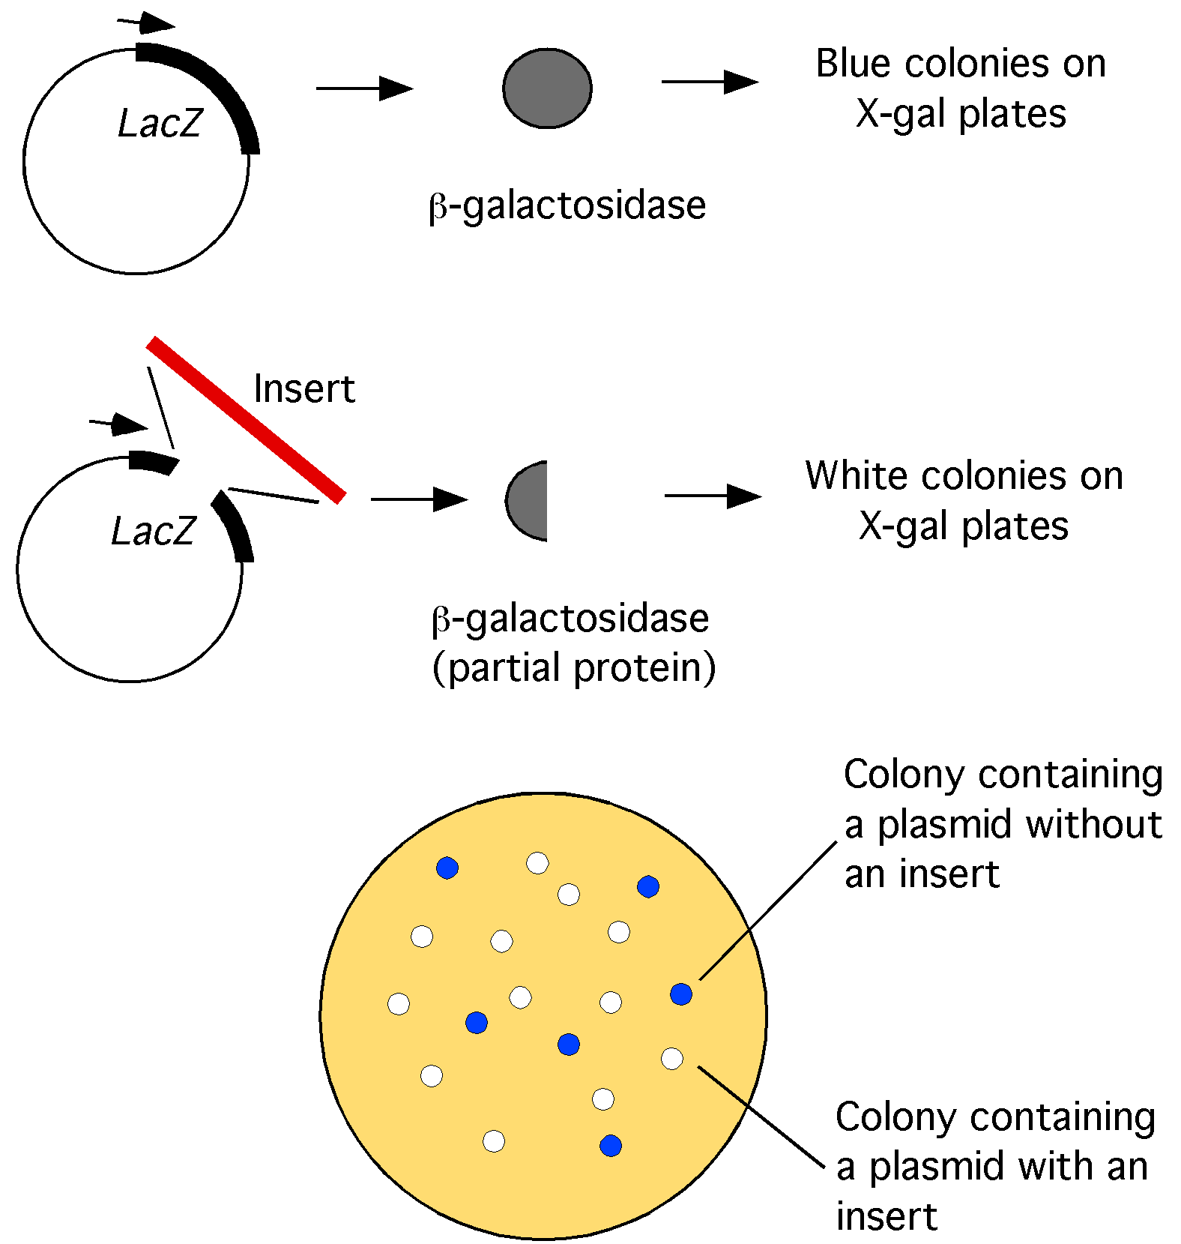
Fig 1-3. Screen for colonies containing inserts. Expression of the lacZ gene produces an enzyme that breaks down the X-gal compound, producing a blue color. Cloning an insert into the lacZ gene on the plasmid prevents expression of a functional enzyme and the colonies stay white in color.

3. Plasmid cloning vector pTriplEx2

We used the plasmid vector pTriplEx2 to clone the cDNA library. A map of this plasmid is shown below (http://www.clontech.com/images/pt/PT3194-5.pdf ) (Fig 1-4). Most modern cloning vectors use a backbone from the pUC vectors, which were the first high copy stable vectors developed (by Jo Messing, Waksman Institute). This backbone contains a high copy bacterial origin of replication (pUC ori) and the ampicillin selectable resistance marker, Amp^{R}. This plasmid also contains an origin of replication for the f1 bacteriophage (f1 ori), which can be used to produce single stranded DNA of the plasmid for sequencing and mutagenesis.
Below is shown an enlargement of the polylinker cloning site. A polylinker, or Multiple Cloning Site (MCS), is a stretch of DNA that contains multiple contiguous restriction sites in the lacZ gene to facilitate the cloning of DNA. Unique restriction sites in the plasmid are shown. The plasmids that you will be working with contain cDNA fragments that were cloned into the SfiIA and SfiIB sites (arrows).
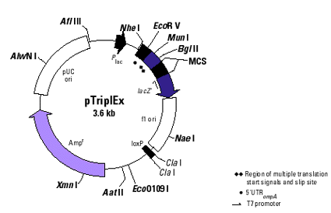
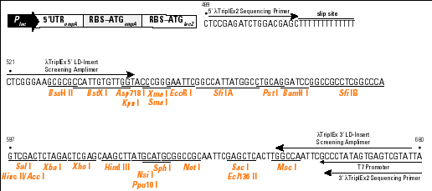
Fig 1-4. Map of pTriplEx2 vector. The sequence of the polylinker (MCS) is shown with the restriction sites. The duckweed cDNA inserts were cloned into the SfiI sites.
pTriplEx2 has the E. coli lac promoter and operator to provide regulated expression of inserts in E. coli. The 5' untranslated region (UTR) of the mRNA is from the E. coli ompA gene stabilizes the mRNA, thereby increasing expression. pTriplEx2 incorporates translation initiation signals from the E. coli ompA gene. Downstream of this is the pTriplEx2 MCS, which is embedded within the lacZ alpha-peptide allowing clones with inserts to be identified by blue/white screening in an appropriate host strain. The ampicillin resistance gene and pUC origin of plasmid replication allow selection and propagation, respectively, of pTriplEx2 in E. coli.
cDNA insert
4. DNA Libraries
The goal of our research project is to identify genes that are expressed in the organism we are studying. To do this we must isolate nucleic acid fragments from the organism and analyze their sequence. To accomplish this scientists make random DNA libraries. A DNA library is essentially a random collection of DNA fragments that ideally contains at least one copy or more of every DNA sequence in a particular organism. A DNA library is useful because it can be easily maintained in the laboratory, and it can be manipulated in various ways to facilitate the isolation of a DNA fragment of interest to a scientist. Numerous types of libraries exist for various organisms.
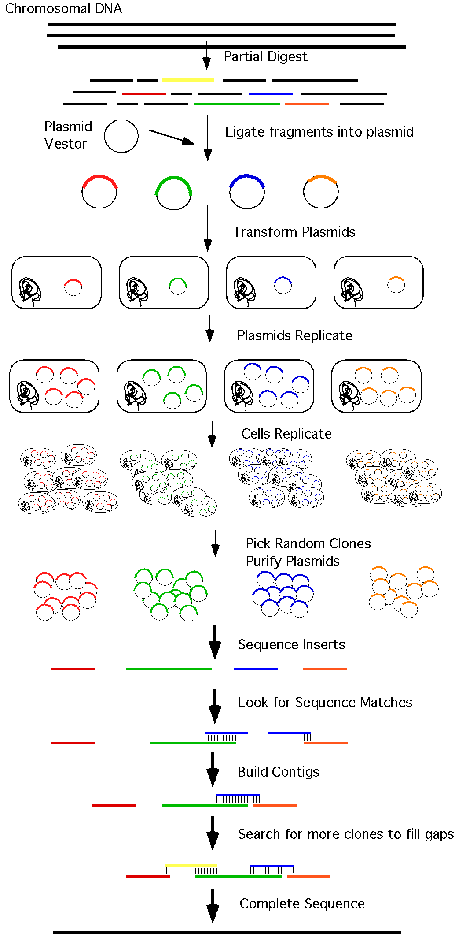
Fig. 1-5. Constructing a genomic DNA library to use in determining the genome sequence.
a) A genomic library consists of collection of randomly generated DNA fragments from an organism’s genome. This includes regions of the genome that code for proteins, as well as non-coding regions, such as introns, regions between genes, telomeres and centromeres. Genomic DNA libraries are used to determine entire genome sequence of an organism or to isolate the non-transcribed regions of a gene, such as its promoter or introns.
Genomic DNA libraries are usually made by purifying chromosomal DNA from an organism and breaking it up into random fragments of 5-100 Kb (kilobases: 1000 base pairs) by partial digestion with a restriction endonuclease (see Ch 2) (Fig 1-5). The random collection of DNA fragments are then ligated into a vector backbone and transformed into bacteria. Each individual bacterial transformant (clone) will contain a different fragment of the genome. All of the plasmids in a particular cell will contain the same insert. As the plasmid replicates there will be 50-100 copies of the plasmid in each cell. In addition, each cell will replicate so there may be over a million cells in one colony on a Petri plate.
To sequence the genome, scientists pick individual clones, purify the plasmid DNA, and sequence the genomic DNA insert. The scientists then use computer programs to compare the sequences of the clones with each other. If they determine that two sequences overlap with each other (such as the blue and green fragments in Fig 1-5) they can build a composite sequence called a contig that incorporates both sequences. By continuing this process of analyzing random clones from the library they can eventually form a contig that spans the whole genome.
b) A second type of DNA library used by scientists is called a cDNA library (Fig 1-6). A cDNA library represents only the DNA that is expressed as mRNA, which is later translated to produce proteins. cDNA refers to “complementary” DNA — DNA which is complementary to mRNA. In this research project, we will use cDNA libraries because we are primarily interested in DNA that codes for proteins. (Note: Although these libraries are good, they are not free or deserving praise so they are not “complimentary”).
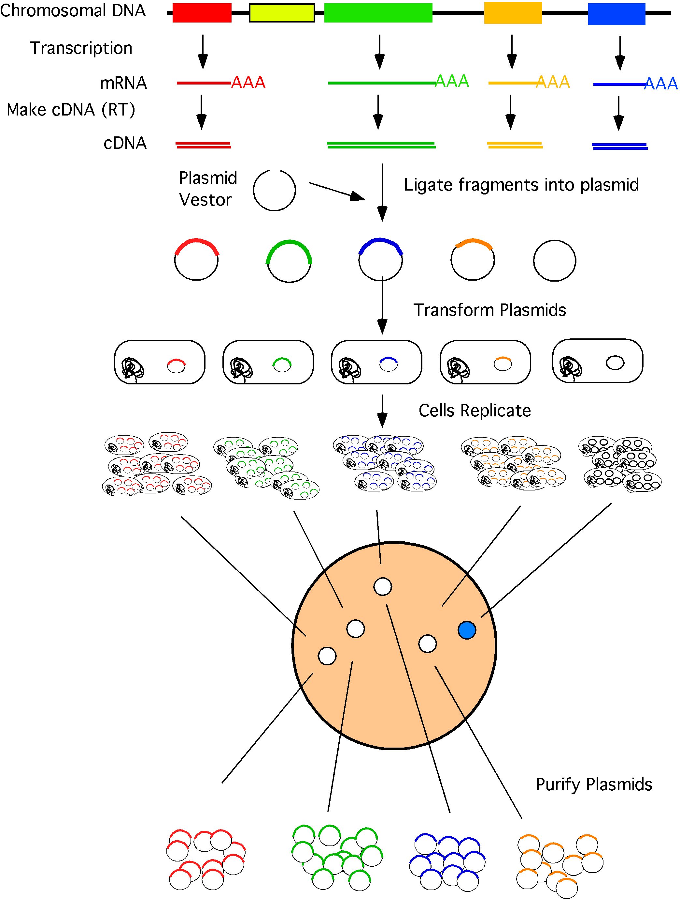
Fig 1-6. Construction of a cDNA library
cDNA libraries are also used in genomic sequencing projects. By sequencing a cDNA library, efforts are restricted to genes that encode proteins. cDNA sequences help "decode" the genome sequence by identifying specific protein-coding regions. For example, the genome of the soil nematode C. elegans is thought to encode approximately 19,000 genes. However, there is a lot of DNA that is not devoted to coding genes. Non-coding genomic DNA can be used for regulatory purposes or introns, can make up the ends of chromosomes (telomeres), or may be simply vestigial (often referred to as “junk” DNA).
cDNA libraries can be constructed to include sequences of different groups of expressed messages using mRNA extracted from organisms at specific stages of development or from organisms grown under “stressed” conditions, such as low nutrient availability. Alternatively, RNA can be extracted from isolated tissues. This results in the construction of a library of genes expressed under the specified conditions in a specific tissue. For example, a cDNA library constructed using mRNA from an embryo would be enriched in genes that are involved in the development of the organism. In contrast, many of these genes may not be present in a cDNA library made from a mature adult, where these genes are no longer expressed. In the figure for example, since the yellow gene is not expressed, there will be no clones containing this DNA in the library (Fig. 1-6)
One challenge of the genomic sequencing projects is to identify ALL the cDNAs expressed in an animal. Remember, some genes are expressed only at specific stages and some only in specific cells, thus the cDNA for such a gene would be expected to be rare in a pool, like the transcript to which it corresponds. Genes that are expressed at low levels, only in certain cells, or only at certain times might be missed in an overall effort to sequence all the cDNAs (Fig 1-7). If you were systematically matching cDNA sequence to the genome, you might miss many such genes. Also, remember that it will not be possible to identify non-transcribed regulatory sequences such as 5’promoter regions, since they are not included in the transcript or cDNA.

c) Making a cDNA library
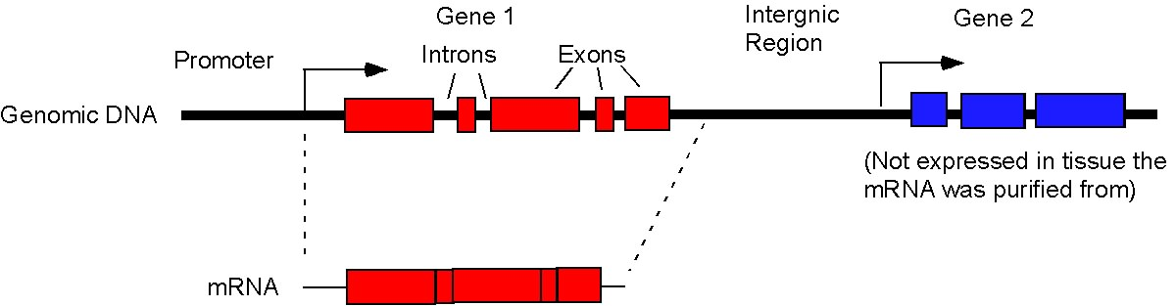
Fig 1-7 Differences between a Genomic and cDNA Library. A genomic library contains all coding and non-coding regions of the genome. A cDNA library will only contain sequences corresponding to mRNA of expressed genes (red mRNA). Genes that are not expressed (blue gene) or non-coding intergenic or intron regions will not be present in a cDNA library.
The library we are going to use in this project is a cDNA library from a species of duckweed. Since you will be spending a fair amount of time analyzing the DNA sequences from this library, it is important to have a good understanding of how it was constructed.
To make a cDNA library one must first isolate mRNA from the organism of interest. We have isolated mRNA from a mixed age population of duckweed to maximize the diversity of sequences cloned. Unfortunately, once the RNA is purified, it is difficult to continue further experimentation. RNA, which is a single-stranded nucleic acid, cannot be directly cloned or easily sequenced. Moreover, RNA is much less stable than DNA and can degrade quickly. To get around these problems, molecular biologists have developed a technique that allows one to derive double-stranded DNA molecules from single-stranded RNA. The DNA can then be cloned into a vector that makes it easy to produce more nucleic acid for further study.
The double-stranded derivative of a single-stranded RNA is known as cDNA. The protocol for generating cDNA is used by scientists studying many different biological problems, and is described below.
1) Isolate RNA from the organism. Live duckweed was collected frozen in liquid nitrogen and ground up with a mortar to break open the cells, releasing the proteins and nucleic acids (DNA and RNA) into solution. The insoluble cell debris (cell wall, cell membranes, etc) were then pelleted by centrifugation. Nucleic acids were extracted from the soluble fraction using phenol to remove proteins. Total RNA was then precipitated using lithium chloride and ethanol, which favors the precipitation of RNA (as opposed to DNA).
2) Purify poly-A containing RNA (messenger RNAs). All eukaryotic cells contain three RNA polymerase enzymes. RNA Pol I and RNA Pol III transcribe noncoding RNAs, which include the structural RNAs present in the ribosome (rRNA), the main translational machinery of the cell, and transfer RNAs (tRNA). RNA Pol II transcribes everything else (e.g., the protein coding genes). Since we are primarily interested in genes that encode proteins, we want to isolate the Pol II products (mRNA).
mRNA comprises only a few percent of the total cellular RNA. How can we separate it from the large excess of rRNA and tRNA? Fortunately, almost all Pol II transcripts (mRNAs) are distinguishable from Pol I and Pol III transcripts by the presence of a run of adenosine nucleotides, known as the poly-A tail. The poly-A tail is added to the 3' end of newly transcribed mRNA after transcription is complete; the poly-A tail is not encoded by the DNA.
To purify the poly-A tail-containing mRNA away from the rRNA and tRNA, the total RNA is passed over an oligo-dT column (Fig. 1-8). The poly-A containing mRNA will hybridize to the oligo-dT and stick to the column. In contrast, the rRNA and tRNA will flow through. After washing to remove as much of the contaminating RNAs as possible, the poly-A mRNA is then eluted from the column to obtain a solution of mostly mRNA.
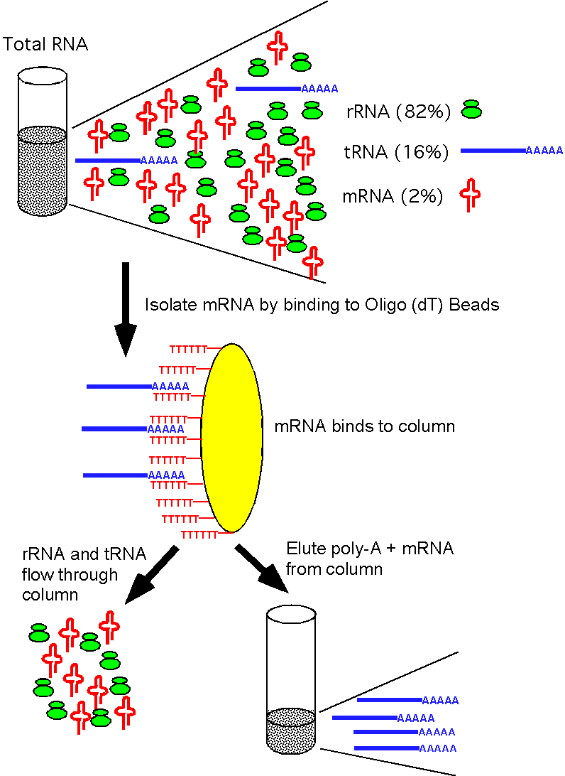
Fig 1-8. Purification of poly-A containing mRNA
3) Reverse transcribe the mRNA. During this process single-stranded DNAs, complementary to the mRNAs, are generated using an enzyme known as Reverse Transcriptase (Fig 1-9). Reverse Transcriptases (RT) are derived from a class of viruses known as retroviruses. Retroviruses have RNA genomes, but during their infection cycle they pass through a DNA phase. The reverse transcriptases carry out the conversion of RNA into single-stranded, complementary DNA. The process of reverse transcription is shown in the following diagram:
Reverse transcriptase cannot synthesize DNA de novo from an RNA template—like all DNA polymerases, it can only extend from a preexisting primer. Thus, to make cDNA, an oligo(dT) primer (a nucleotide string of T’s), nucleotides, and reverse transcriptase are added to the RNA mixture, and the reaction is incubated under conditions favored by reverse transcriptase. The oligo(dT) primer hybridizes to the poly-A tail at the 3’ end of the gene (or sometimes, unfortunately, to a patch of continuous A bases elsewhere in the RNA!). This primer has an SfiI site at the end for cloning into the SfiIB site of the pTriplEX2 vector. The reverse transcriptase then initiates synthesis of the cDNA strand. When the RT reaches the end of mRNA template, instead of falling off, it uses a terminal transferase activity to add several C bases to the end of the cDNA (Fig 1-9). The end result is a double-stranded molecule containing one DNA and one RNA strand (a DNA:RNA hybrid). This process is known as “first strand synthesis.” This hybrid molecule, however, is not useful because it is composed of both DNA and RNA.
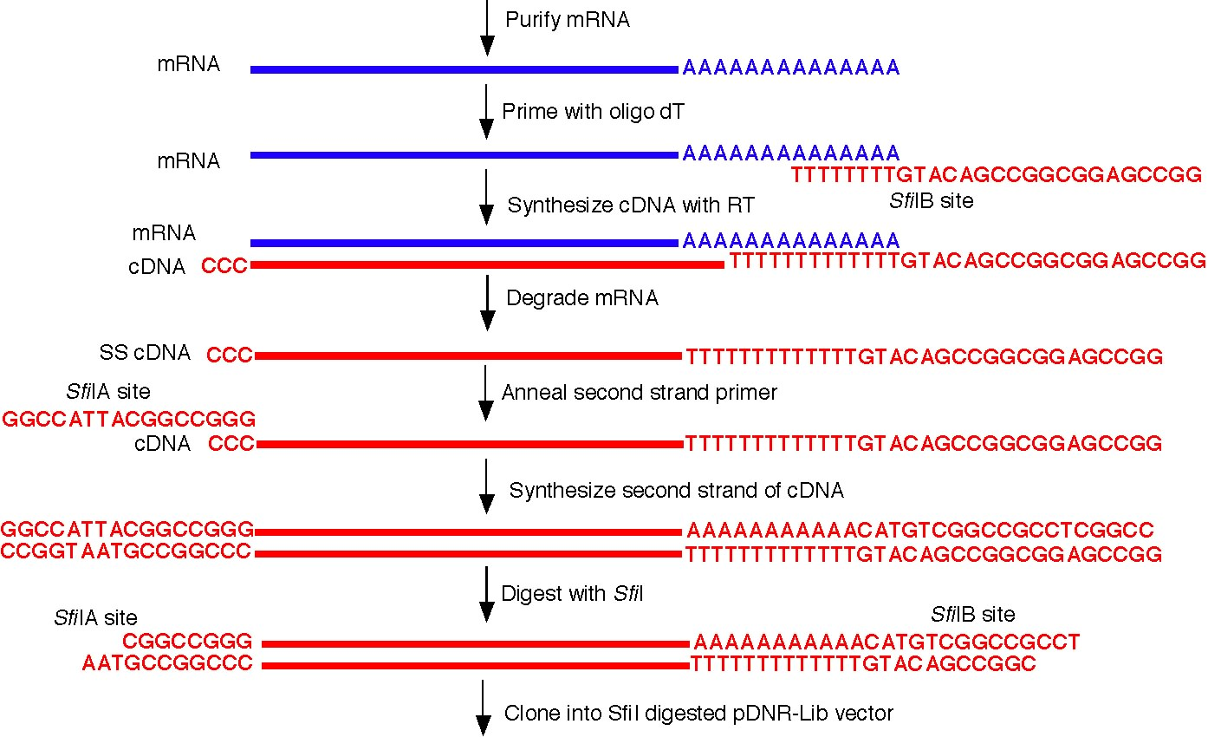
Fig. 1-9 Synthesis of cDNA from mRNA.
4) Remove the RNA part of the RNA:DNA hybrids. This can be accomplished in several ways. In one method, the RNA is hydrolyzed by treatment with a strong base (sodium hydroxide). Under these conditions, the DNA strand remains intact while the RNA strand is degraded. In an alternative method, the enzyme RNAse H is used to specifically degrade the RNA part of an RNA:DNA hybrid. At this stage of the procedure, we have a mixture of single-stranded cDNAs that are complementary to the mRNAs isolated from the organism we are studying.
5) Perform the second strand synthesis. At the end of all the procedures described above, we have a mixture of single-stranded cDNAs. In the first step of the eventual cloning of these molecules, single-stranded cDNAs are copied into double-stranded ones. This is done with yet another enzyme, DNA polymerase. DNA polymerase works in an analogous fashion to reverse transcriptase, with the exception that it makes a DNA copy from a single-stranded DNA (not RNA) template. However, DNA polymerase activity requires a primer from which it initiates synthesis of the complementary strand. A single-stranded oligonucleotide primer is used which anneals to the short runs of C’s at the 3’ end of the single-stranded DNA molecule. This primer also contains an SfiI site for cloning into the SfiIA site of the pTriplEX2 vector. DNA polymerase is then used to synthesize the complementary strand, creating the double-stranded molecules.
6) Ligate double-stranded cDNAs into pTriplEX2 vector. The pool of cDNA fragments is then digested with the restriction enzyme SfiI to generate ends of the DNA with overhangs to aid in cloning into the vector (Fig 1-9). This enzyme recognizes an 8 bp sequence, so it cuts very infrequently (on average once per 65 Kb) (Fig 1-10). The odds are therefore very unlikely that it is going to cut within the cDNA fragment. The enzyme also has the property that it will recognize a specific site but will leave degenerate ends. For example, pTriplEX2 has two SfiI sites, SfiIA and SfiIB, which have different overhangs at their ends. This means that the SfiIA and SfiIB sites cannot ligate to each other and the vector will not circularize without an insert. The ends of the cDNA fragments also contain different overhangs. The end near the 5’ end of the mRNA transcript contains an overlap that will hybridize to the pTriplEX2 SfiIA site. The end near the poly-A tail at the 3’ end of the mRNA contains an overlap that will hybridize to the pTriplEX2 SfiIB site. This has the advantage that the cDNA fragments will always be cloned in the same direction.
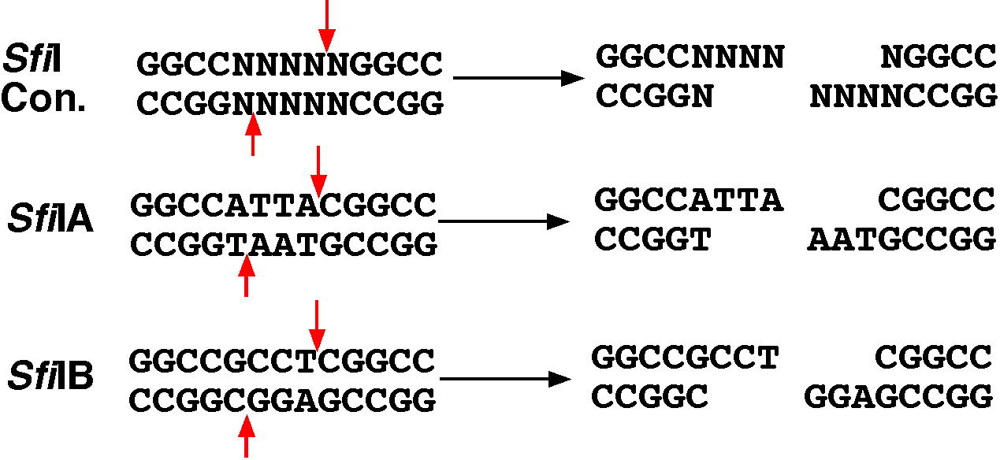
Fig. 1-10 SfiI sites of pTriplEX2. The SfiI consensus site is shown on the first line and the plasmid sites are below.
The pool of SfiI digested cDNA fragments is then pasted into SfiI digested pTriplEX2 vector. This is accomplished using an enzyme known as DNA ligase, which covalently links ends of DNA molecules. Note that the SfiIA and SfiIB sites flank the PstI and BamHI sites in the polylinker of the vector. The PstI and BamHI sites will therefore be deleted when the cDNA insert is cloned into the SfiI sites (see map of the polylinker Fig 1-11)

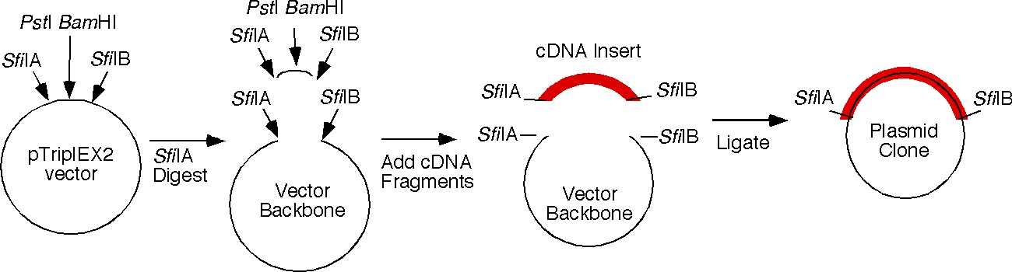
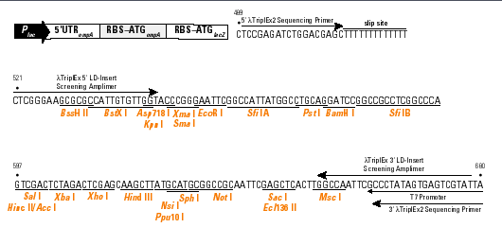
cDNA
Fig 1-11. Multi-purpose cloning site (MCS) of pTriplEX2. The cDNA was cloned between the SfiIA and SfiIB sites so the PstI and BamHI are no longer there.
7. Transform bacteria. The ligation mixture is then transformed into bacteria as described earlier in this Chapter and plated on LB-agar media with ampicillin to select for transformed cells. The end result is a cDNA library. It is called a library because like a library that contains numerous different books it consists of a population of many different cDNAs all in the same type of vector.
In summary, important things to remember about the WSSP cDNA library are:
1) Clones have cDNA rather than genomic DNA--this means the clones have no introns and are expected to code for a protein. The clones may also have sequence outside of the actual protein coding sequence, because mRNAs are synthesized with 5' and 3' untranslated regions.
2) cDNAs in this library represent genes that are expressed in the organism, most of which are probably expressed at a reasonably high level.
3) Unfortunately, you have to be careful--sometimes a cDNA library has clones that are not from mRNA, but from genomic DNA contamination. How would you tell the difference between the two? How does the sequence of mRNA differ from genomic sequence?
5. Preparing Plasmid DNA
In order to use a vector for cloning, sequencing, etc., it is necessary to isolate the vector in a highly purified form. This is an important technique, and is routinely done by most labs. You will be learning procedures used by many labs for purifying plasmids. Remember, these are not simplified procedures and are in fact, routinely used in our labs.
Alkaline Lysis Plasmid Minipreps:
One of the most commonly used techniques performed in a molecular biology laboratory is the isolation of plasmid DNA from small cultures of bacteria. The DNA isolated by these miniprep procedures is often sufficient in quantity and purity to perform several sequencing reactions, to analyze an unknown fragment of DNA by restriction enzyme digestion, to serve as a PCR template, to be used to transform various bacterial strains, or to use in subsequent cloning steps. The most common use of miniprep DNA is to screen many different plasmids for the presence of the desired DNA fragment after cloning. The DNA from these preps is digested with restriction enzymes to determine if the desired construct was obtained (discussed in more detail in Chapter 2). The yields of the amount of DNA can vary depending on the type of plasmid that you are working with. However, for a standard pUC based plasmid, yields are usually in the range of 3-6 ug of DNA/ml of culture.
There are many different types of DNA miniprep procedures. The most common procedure is called an alkaline lysis miniprep. Many companies now sell kits that provide all of the reagents and protocols to do a DNA miniprep. The procedures in these kits are usually variations of the alkaline lysis procedure and frequently contain an extra step in which the plasmid DNA is further purified by a chromatography step. When you enter a lab, it is always good policy to see how they do their minipreps in case there are special considerations of which you need to be aware.
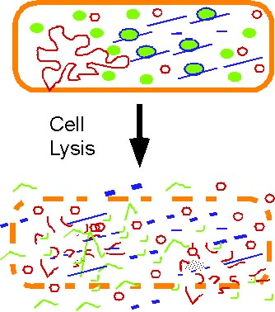
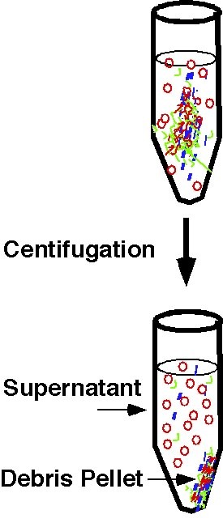
Fig 1-12 Basic Steps of an alkaline lysis miniprep.
In general, most minipreps start out with a gentle lysis step to break open the cells and release the plasmid DNA into solution (Fig 1-12. Conditions are chosen such that the cell debris and chromosomal DNA of the bacteria is pelleted during the centrifugation. The plasmid DNA, however, remains behind in the clear non-pelleted fraction (the non-pelleted solution left after centrifugation is known as the supernatant). Other steps such as ribonuclease I (RNAse I) treatment, phenol extraction, binding to affinity columns) are then performed on the supernatant to remove contaminating RNA and proteins from the plasmid DNA. As a final step, the plasmid DNA is usually precipitated with ethanol or eluted from the column and stored in a suitable buffer, e.g., water or TE. This step provides further purification of the plasmid DNA from proteins and small molecules and concentrates the plasmid DNA into a small volume. Below, the steps of the miniprep protocol that we will use in Lab 5 are outlined. Below each step is a brief explanation of why each step is performed.
6. GE MicroPrep Kit Protocol (See video on performing a miniprep)
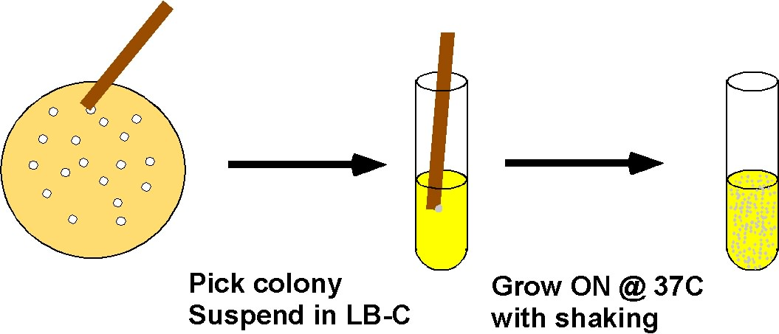
Fig 1-13 Set up an ON culture. A toothpick is used to transfer cells from a white colony on LB-Amp plate to liquid LB-Amp and grown with shaking overnight.

1. Grow an overnight (ON) culture of the desired bacteria in 2 ml of LB medium containing the appropriate antibiotic for plasmid selection. Incubate the cultures at 37°C with vigorous shaking. (Fig 1-13)
Although it is possible to isolate small quantities of plasmid DNA from a colony of cells growing on a plate, usually there is not enough plasmid DNA isolated for sequencing or for more than two restriction digests. It is therefore necessary to amplify the number of cells before the DNA prep is started. Most bacteria grown with aeration at 37˚C in LB will reach saturation density after an overnight (ON) growth (usually greater than 6 hrs). A freshly saturated culture will contain roughly 2 X 109 cells/ml, while a large colony on a plate will only contain about 107 cells. The ON culture can be stored at 4˚C for a couple of days before performing the miniprep, but the quantity and quality of the DNA will decrease.
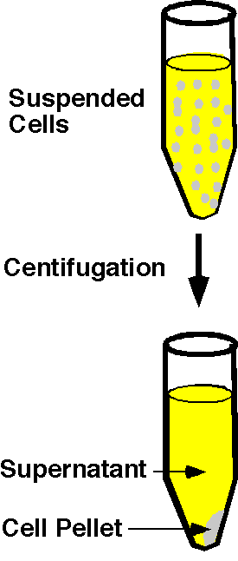
Fig. 1-14 Pellet cells

2. Transfer 1.5 ml of the culture to a microcentrifuge tube and pellet the cells by centrifugation for 1 minute at full speed in a microcentrifuge (Fig 1-14). Remove and discard the medium (supernatant), leaving the bacterial pellet as dry as possible.
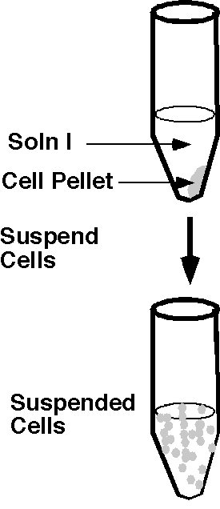
Fig 1-15 Suspend cells in Soln I.
This step concentrates the cells into a small volume and removes any salts, DNA, RNA, proteins and cell wastes that were floating in the media. Centrifuging the culture concentrates the cells to the bottom of the tube. This mass of concentrated cells is called the pellet. The liquid in the tube is known as the supernatant.
.
3. Resuspend the bacterial pellet in 200 µl of Solution I by vigorous vortexing. It is essential that the pellet be completely dispersed in solution. (Fig 1-15).
Solution I contains three essential components: 100 mM Tris (pH 7.5), 10 mM EDTA and 400 ug/ml Rnase I. The Tris is used to buffer the pH of the cell suspension from very acidic or basic conditions. The EDTA is a chemical that chelates divalent cations (ions with charges of +2) in the suspension such as Mg++. Chelaters remove ions from a solution by forming a chemical complex with them, thereby effectively removing them from solution. This chelation serves two purposes. First, the outer cell membrane of bacteria is stabilized by Mg++ ions — by removing them with EDTA, the outer membrane breaks down. Second, and more importantly, most enzymes that degrade or cleave DNA require Mg++ ions to function. Thus, the addition of the EDTA reduces the degradation of the plasmid DNA by nucleases found inside bacteria cells. RNase is an enzyme that specifically degrades RNA. A large portion of the nucleic acids in the cell is RNA (rRNA, tRNA and mRNAs). The presence of these nucleic acids will hinder some of the reactions on your DNA and make it difficult to purify your plasmid. Adding this enzyme will digest the RNAs into small fragments or single nucleotides that will not purify with the plasmid DNA.
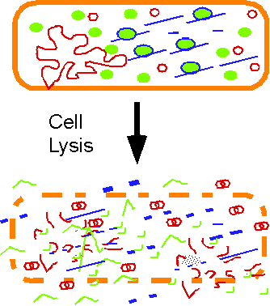
Fig 1-16 Cell Lysis. Chromosomal and plasmid DNA (red), proteins (green), RNAs (blue) and membranes are denatured and unfolded in high pH.
Note: In the WSSP project students will suspend the cell pellet in Solution I and then store the tubes at -20ºC until they are ready to continue to perform the miniprep.

4. Add 200 µl of Solution II and mix gently by inverting 5 times. Do not vortex.
Close the tube tightly and mix the contents by slowly inverting the tubes ten to fifteen times. Solution II contains 0.2 N NaOH (a strong base) and 1%SDS (a detergent) to lyse (break open) the bacteria to liberate the plasmid DNA and other cellular components (Fig 1-16). After inverting 4-6 times you will notice the formation of a viscous bacterial lysate. No incubation is necessary. Go immediately to the next step.
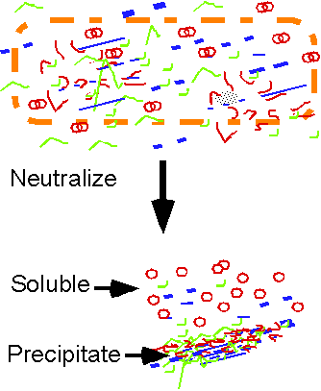
Fig 1-17 The addition of acid allows the plasmid to renature and is soluble. Chromosomal DNA, RNA and proteins aggregate with each other and form a precipitate.

After lysing the bacteria, the NaOH in Solution II then denatures all double-stranded nucleic acids (e.g., chromosomal and plasmid DNA become single stranded) in the cell. In addition, the SDS in Solution II binds and denatures the bacterial proteins. During this step a viscous bacterial lysate forms. The high viscosity is mainly due to the long, denatured chromosomal DNA.

IMPORTANT TECHNICAL TIP: You should not be too vigorous in mixing the cells after addition of Solution II because the chromosomal DNA may shear into small fragments. It is recommended that you mix your lysate-Solution II gently by inverting the tube by hand.

5. Add 400 µl of Solution III and mix gently by inverting 5 times. Do not vortex.
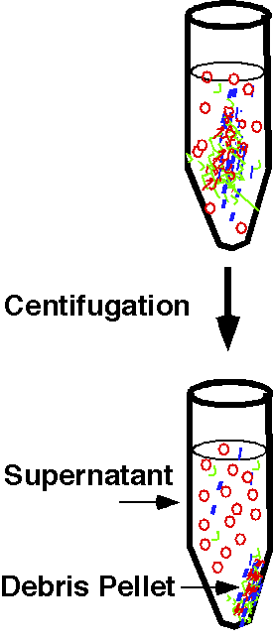
Fig 1-18. Centrifuge the renatured sample. The plasmid DNA is in solution in the supernatant.
Solution III contains low pH (acidic) sodium acetate salt to neutralize the high pH of Solution II used in step 4. At neutral pH, nucleic acids attempt to renature (reanneal). Since plasmids are covalently closed circles, the two single strands produced by denaturation remain physically linked (Fig 1-17). Therefore the denatured plasmid DNAs rapidly reanneal when the pH is neutralized. Chromosomal DNA, however, is linear, so the strands fully separate during denaturation. Thus, the renaturation of chromosomal DNA, unlike plasmid DNA, is inefficient. Moreover, the salt ions in Solution III form an aggregate with the protein:SDS complexes and immediately precipitate them. Thus, when the pH is neutralized, a protein precipitate forms before the chromosomal DNA has a chance to renature. As a result, the chromosomal DNA is trapped in the protein precipitate. The plasmids, however, reanneal fast enough that they are not trapped in the precipitate, and hence remain soluble. Solution III also contains a high concentration of a chaotropic salt that promotes binding of the plasmid DNA to the spin column in a later step.

It is important to mix gently, because vigorous shaking may break the genomic DNA, which may co-purify with the plasmid DNA. After inverting 10-20 times you will notice the formation of a white precipitate consisting of cell debris and SDS. No incubation is necessary. Go immediately to the next step.
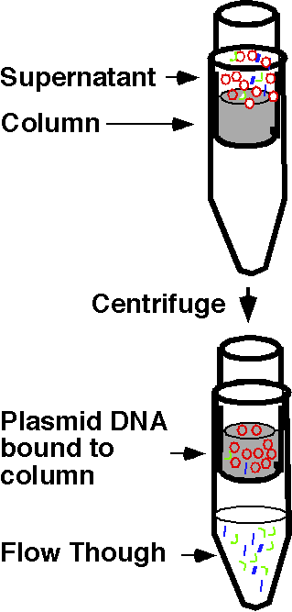
Fig 1-19. Spin column binds the plasmid DNA while protein and RNA flow through.

6. Centrifuge for 5 minutes at full speed in the microcentrifuge.
A white pellet consisting of cell debris, SDS, and chromosomal DNA will form on the bottom and side of the tube after centrifugation (Fig 1-18). Your plasmid DNA will remain in the supernatant. During this centrifugation step, place the necessary number of spin columns into the respective number of 2-ml microcentrifuge collection tubes and label each spin column appropriately.

7. Transfer the supernatant to the appropriately labeled spin column that has been inserted into the 2-ml Collection tube by pouring the sample onto the column. Incubate at room temperature for 1 minute before spinning in step 8. (Fig 1-19).
Make sure you transfer the superNATANT. Do not transfer the white precipitate. It is important to not contaminate the spin column with the white precipitate, which contains cell debris. If too much precipitate is included in the transferred liquid, the column will get clogged and the purification will fail. It is better to leave some liquid in the tube that was centrifuged, resulting in a debris-free supernatant, rather than try to get all of the solution, which may be contaminated with precipitate. You will get more than enough DNA in the prep for your analysis (sequencing, PCR, restriction digests, transformations, etc).

8. Centrifuge for 1 minute at full speed, and drain the flow-through from the Collection Tube. (Fig 19)
Working with one sample at a time, remove each spin column from the 2-ml collection tube and pour the flow-through (the liquid that passed through the column and into the bottom of the collection tube) into a temporary liquid waste container such as a 50-ml conical tube (Fig 1-19). Place each spin column back into the 2-ml microcentrifuge collection tube.

The plasmid DNA will stick to the column. RNA, proteins, and denatured chromosomal DNA should not stick to the column and will come out in the flow through at the bottom of the tube.

9. Add 400 ul of Wash Buffer to the spin column contained in the 2-ml Collection Tube, then centrifuge at full speed for 1 minute.
The Wash buffer is mainly ethanol (80%) with 10 mM Tris and 1 mM EDTA. This step washes contaminates away from the DNA. The Tris keeps the solution buffered and the EDTA chelates any metal ions that could be used by nucleases to degrade the DNA. Failure to perform this step will result in impure DNA, which will not be useful for further manipulations.
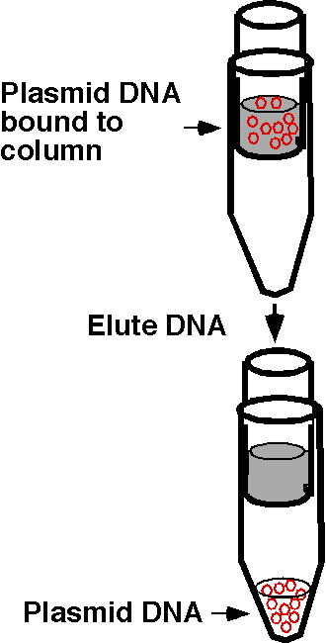
Fig 1-20 Elute DNA from column
10. Place the spin column in a fresh 1.7 ml microcentrifuge tube and centrifuge again for 1 minute at full speed to remove any residual wash solution that might still be in the column.
Any residual wash solution must be removed because the ethanol contained in this solution may interfere with further DNA manipulations.

11. Place the spin column into a fresh appropriately labeled 1.7-ml microcentrifuge tube and add 60 μl of Buffer EB to the center of the column. Incubate at room temperature for 1 minute. Centrifuge at full speed for 1 minute.
This final step elutes (removes) the plasmid DNA from the column and brings it back into solution (Fig 1-20). After spinning, your microcentrifuge tube should contain your purified plasmid DNA in 60 μl of Buffer EB.

