AP Lab 11: Blood – REV 2 Block #: _____ Table #: _____ Names: _________________________

BLOOD LAB

Activity 1: PLASMA
List the Physical Characteristics of Plasma in the Right Column
Plasma Characteristics
pH
list normal pH & pH range
Color
Clarity
Consistency

List Major Constituents (Left Column) of Plasma & their Functions (Right Column)

Plasma Constituents | Major Functions of the Constituent(s):  List 3
Water
Salts (Electrolytes):
List the 4 main electrolytes reported when ordering a Chem 7 Blood Test:

Plasma Proteins:  List 3 main Plasma Proteins | List 1 Function for each Protein you Listed  Function of 1:  Function of 2:  Function of 3:
Activity 2: Microscope Anatomy – Blood Cells
Note: for Each Blood Cell Type, do the following:
- In the Upper Left Box, paste the correct Blood Cell Model Image from the back of the handout.
- In the Upper Right Box, list the distinguishing Physical Features & Functions of the Blood Cell.
- In the Lower Left Box, paste the correct Histology Slide from the back of the handout. Use an Arrow to point out (at least 1) the listed Blood Cell.
- In the Lower Right Box, paste a microscopic photo image taken from your microscope showing the listed Blood Cell. Use an Arrow to point out (at least 1) the listed Blood Cell.

Note: The Color for each cell is in reference to using Wright's Stain. For Agranulocytes, write NA for the Granule Stain Color & what the Granules contain.

Erythrocyte: (RBC)
MODEL | Cell Shape:  Cell Size in Relation to RBC:  Nucleus Shape:  Stain Color:  Granule Stain Color:  Granules Contain:  Function:
HISTOLOGY SLIDE (Provided) | MICROSCOPE IMAGE (Taken in Lab)
NEUTROPHIL
MODEL | Cell Shape:  Cell Size in Relation to RBC:  Nucleus Shape:  Cytoplasm Stain Color:  Granule Stain Color:  Granules Contain  Function:
HISTOLOGY SLIDE (Provided) | MICROSCOPE IMAGE (Taken in Lab)

EOSINOPHIL
MODEL | Cell Shape:  Cell Size in Relation to RBC:  Nucleus Shape:  Cytoplasm Stain Color:  Granule Stain Color:  Granules Contain:  Function:
HISTOLOGY SLIDE (Provided) | MICROSCOPE IMAGE (Taken in Lab)

BASOPHIL
MODEL | Cell Shape:  Cell Size in Relation to RBC:  Nucleus Shape:  Cytoplasm Stain Color:  Granule Stain Color:  Granules Contain:  Function:
HISTOLOGY SLIDE (Provided) | MICROSCOPE IMAGE (Taken in Lab)

Lymphocyte
MODEL | Cell Shape: Round  Cell Size in Relation to RBC:  Nucleus Shape:  Cytoplasm Stain Color:  Granule Stain Color:  Granules Contain:  Function (list for all 3 Cell Sub-Types):
HISTOLOGY SLIDE (Provided) | MICROSCOPE IMAGE (Taken in Lab)

Monocyte
MODEL | Cell Shape:  Cell Size in Relation to RBC:  Nucleus Shape:  Cytoplasm Stain Color:  Granule Stain Color:  Granules Contain:  Function:
HISTOLOGY SLIDE (Provided) | MICROSCOPE IMAGE (Taken in Lab)

Activity 3: LAB TEST
Differential WBC Count - Complete the table below:

List the Types of WBC's in order from most numerous to least numerous | List the Percent of the WBC population that each type of WBC composes
Neutrophils - Never
Lymphocytes - Let
Monocytes - Monkeys
Eosinophils - Eat
Basophils - Bananas

Activity 4: LAB TEST
Hematocrit - Calculate the Percent of following in the micro-capillary tubes:

Hct Normal Tube: _______ Hct Anna: ______ Hct Patient B: ______

Percents in Tubes:

% RBC’s in Normal Tube: _______ % Not-RBC’s in Normal Tube: _______

% RBC’s in Anna’s Tube: _______ % Not-RBC’s in Anna’s Tube: _______

% RBC’s in Patient B’s Tube: _______ % Not-RBC’s in Patient B’s Tube: _______

Activity 5: Blood Typing Dry Lab: Blood is Typed by placing the Patient’s Blood into 3 different Wells. Solution drops containing ANTIBODIES against:
- Antigen A (Blood Type A) are then added to Well Anti-A
- Antigen B (Blood Type B) are then added to Well Anti-B
- Antigen Rh (Rh+ Blood Type) are then added to Well Anti-D

If clumping (clotting) occurs in a Well, then the reaction is considered positive; the Patient has a Blood Type capable of reacting with the same named Antibody. For example, clumping in the Anti-A Well means the Patient has Type “A” Blood. The following 3 symbols denote Clumping or No Clumping in specific Wells:
= No CLUMPING in =’s CLUMPING in =’s CLUMPING in
Well Anti-A or Well Anti-B Well Anti-A or Well Anti-B Well Anti-D (Well Anti-Rh)
Directions: For each Well Dish below, determine the patient’s Blood Type. Also list which well has the Universal Donor & which well has the Universal Recipient.

Patient’s Blood placed in Well Dish | List the Patient’s Blood Type

Activity 6: Blood Typing Wet Lab (Time Permitting): Use the Ward’s Simulated Blood to complete the table below and determine the blood type for each subject.

- For Agglutination you may write Clump

- For No Agglutination you may write No Clump

Subject | Agglutination, i.e. Clumping vs. No Clumping |  |  | Blood Type (including Rh type)
 | Anti-A Serum | Anti-B Serum | Anti-Rh Serum
Slide #1:
Mr. Smith
Slide #2:
Mr. Jones
Slide #3:
Mr. Green
Slide #4:
Mrs. Brown
Unknown X
(Mr. Smith)
Unknown Y
(Mr. Green)

MODEL IMAGES Clips
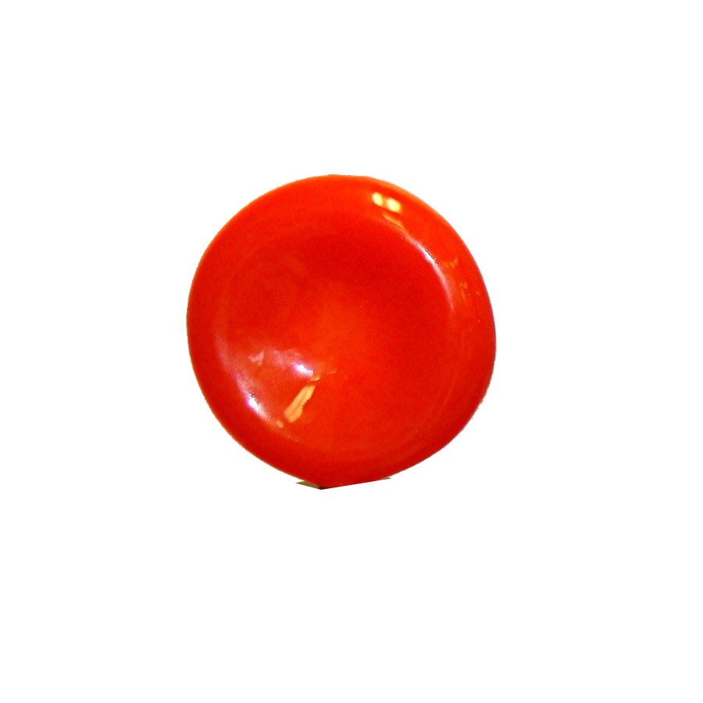
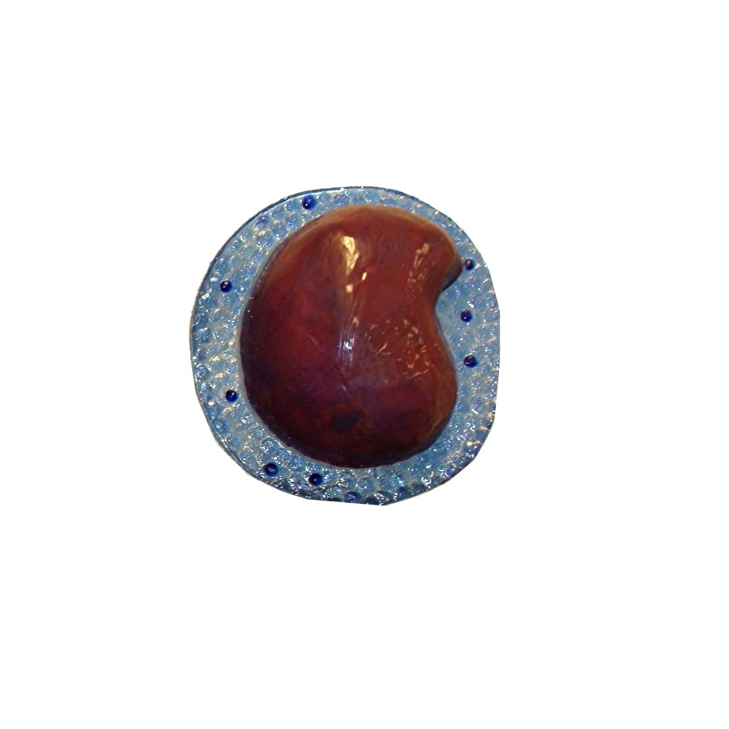
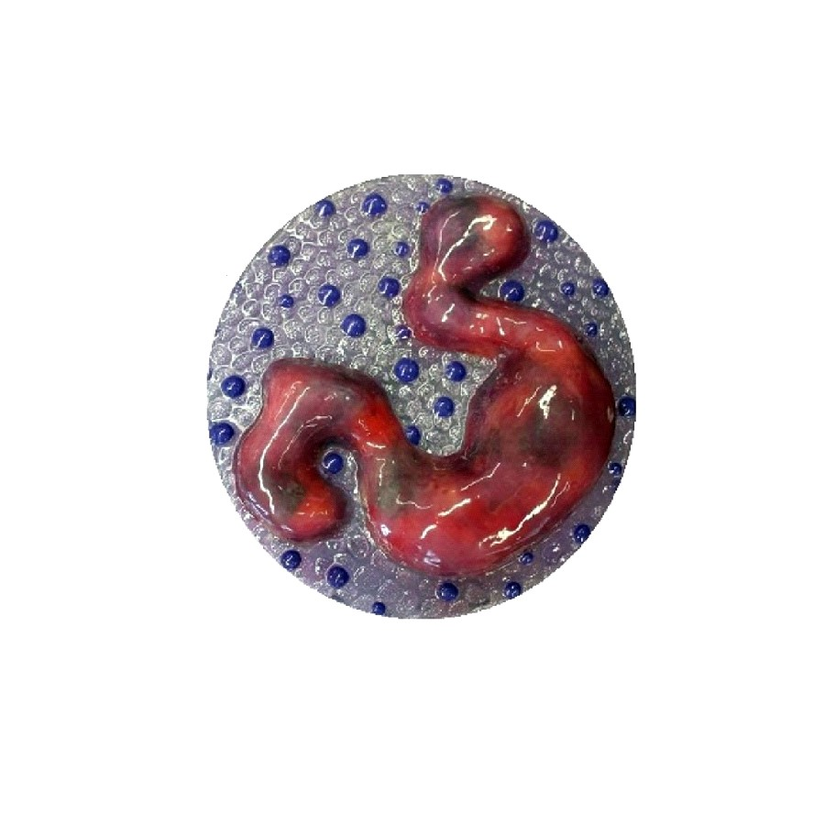
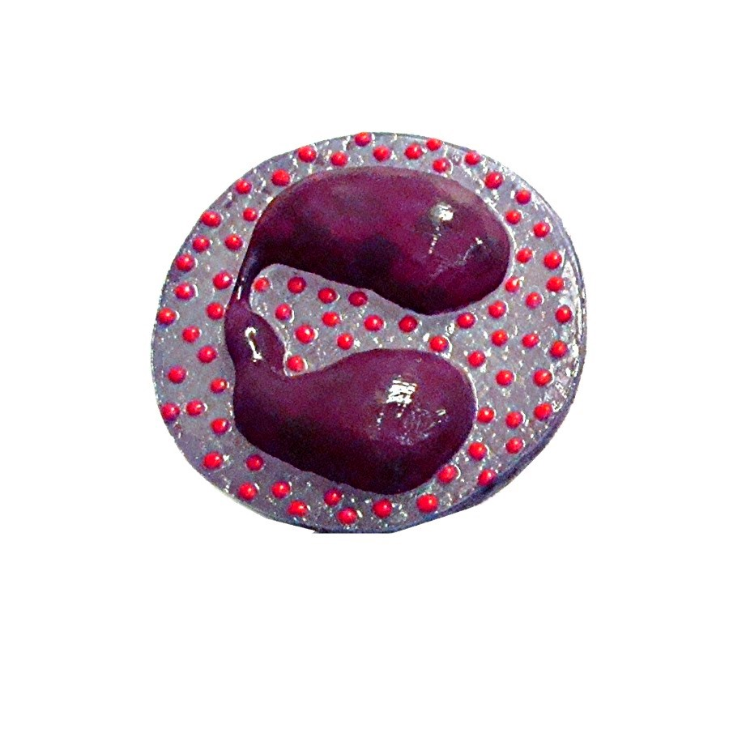
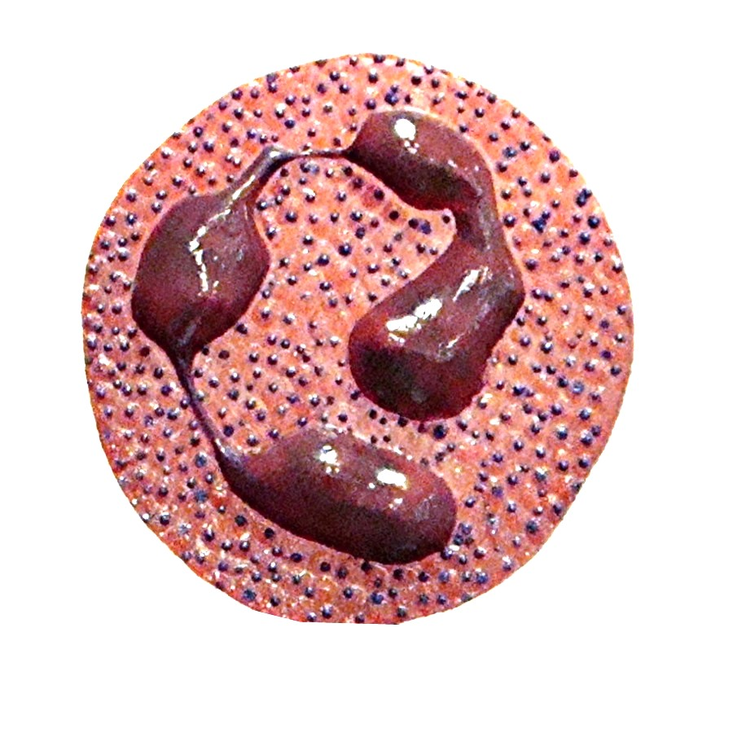
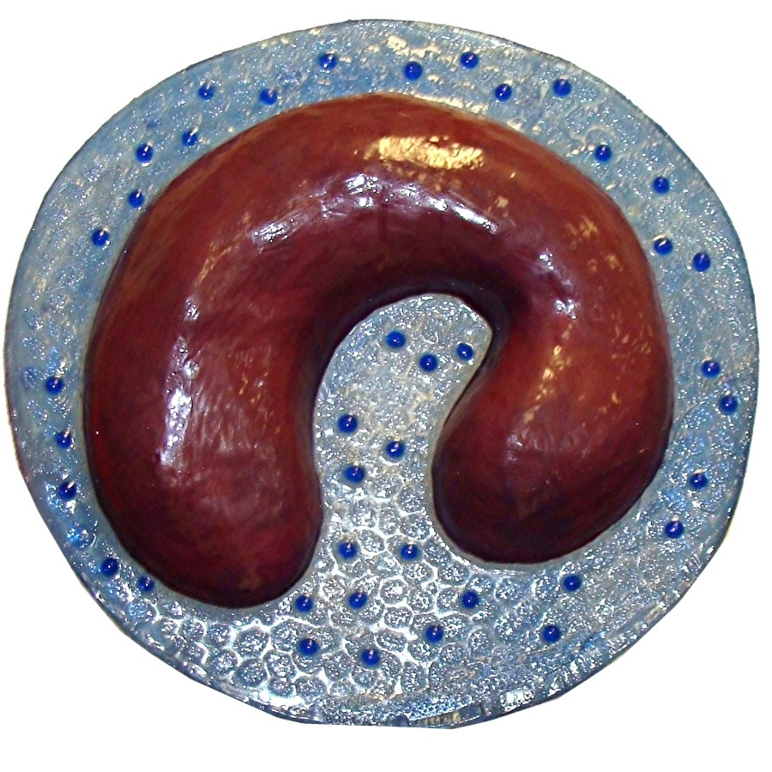

HISTOLOGY SLIDE Clips
