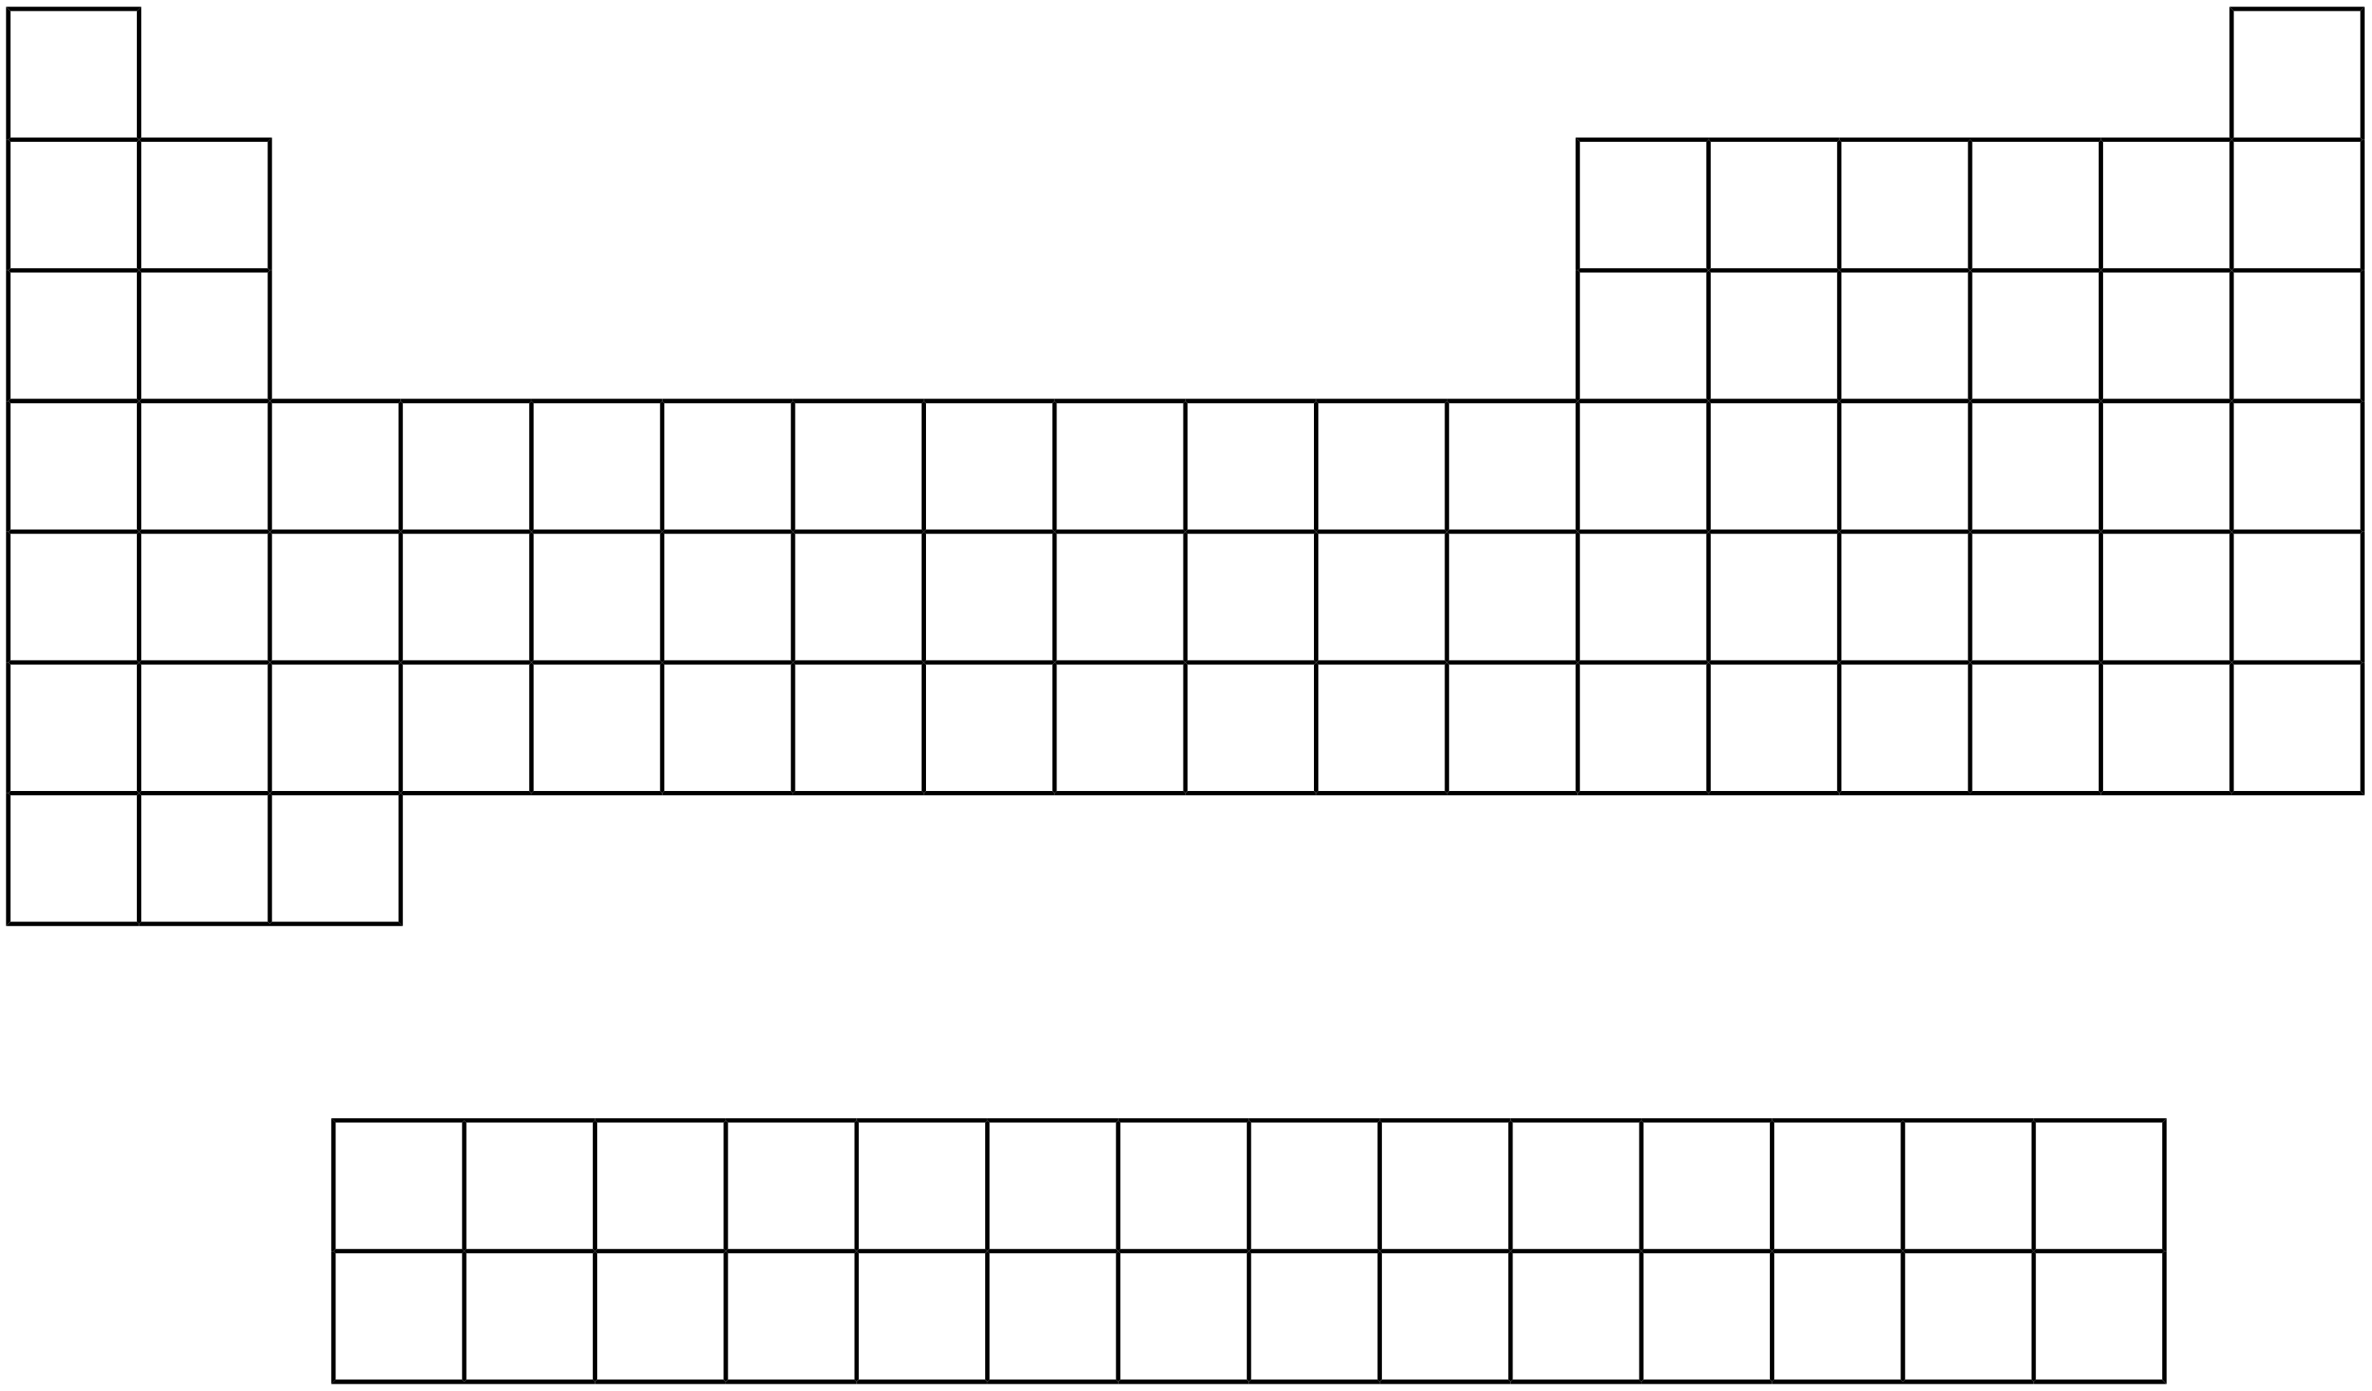

**Alkali Metals:**

**Alkaline Earth Metals:**

**Transition Metals:**

**Inner Transition Metals:**

**Halogens:**

**Noble Gases:**

**Representative Elements:**