* **6.3 Periodic Trends**
* **Atomic Size**
* As you go down the periodic table, the atomic size ________ due to more energy levels
* As you go across, the atomic size ________ because of the ________________ and ____________-
* ________________: the nuclear charge pulls the outer electrons in closer the nucleus
* _____________: when the outer shell is filled with electrons, making the atom the most stable
* **Atomic Size**

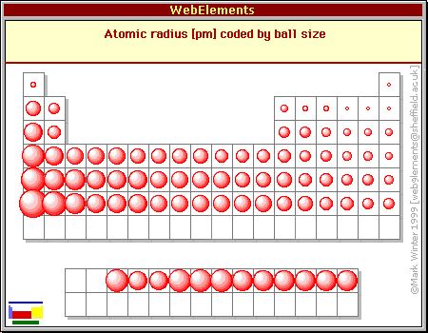

* **Ions**
* Atoms that has a positive or negative charge
* These form when ________________________________________________________________________________________________________________
* _________: positive ion/ loss electrons/ tends to be metals Example (Na+)
* _________: negative ion/ gained electrons /tends to be nonmetals Example (Cl-)
* In the ionic size pairs, metals tend to be _________ when they are ions and nonmetals tend to be __________ when they are ions
* **Electronegativity**
* The ability of an atom _________electrons when atoms are in a compound
* The most electronegative element is ________________
* The least electronegative element is ______________
* Easiest way to determine trend is how ___________________________________________________________________________________

**Electronegativity Trend**

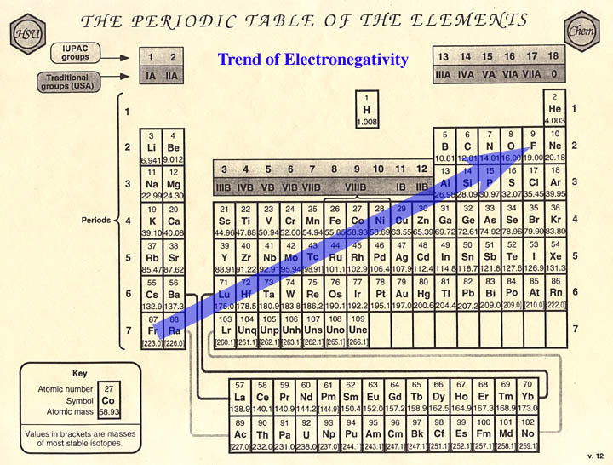

* **Try These Out**
* Put in order of increase atomic size
  + - Nitrogen, Carbon, Boron, Oxygen
* Put in order of higher electronegativity
  + Calcium, Cesium, Magnesium, Aluminum