**Substance Abuse & Adolescents**

**Participant Handout**

**Objectives**

By the end of this training, you will be able to:

1. Describe the **prevalence and impact** of substance abuse in adolescents.
2. Identify the **risk factors and warning signs** of substance abuse issues.
3. **Address an adolescent** with a possible substance abuse issue.

**Early Stages of Teen Substance Use**

|  |  |  |
| --- | --- | --- |
| **Level 1: EXPERIMENTATION** | **Level 2: MISUSE** | **Level 3: EARLY ABUSE** |
| First experiences. | Pattern of use develops. | Skilled at hiding use. |
| Lack of parental knowledge. | Justifications for use (to relax, socialize). | Acquires paraphernalia, plans for use. |
| Low tolerance. | Seeks mood change. | Increased tolerance. |
| Experimental, occasional use. | Use mostly only weekends. | Occasional weekday use. |
| Control & choice are high. | Control & choice are present. | Diminished control & choice. |
| Low consequences. | Some social & personal consequences. | Increased consequences. |



**Warning Signs of Substance Abuse**

|  |  |  |
| --- | --- | --- |
| **Home** | **School** | **General/Other** |
| * Changing attitudes towards rules * Less participation in family activities * Isolating, staying in room much of the time * Talkativeness * Breaking curfew, sneaking out at night * Items disappear from home: money, alcohol, medications * Lying and blaming others for problems * Depression or overactivity * Drug-related room decor | * Missed or poorly done assignments * Decrease in class participation * Shorter attention span * Decrease in concentration * Frequent visits to bathroom or health office * Frequent tardiness &/or absence * Sleeping in class * Disrespectful to teachers * Suspensions, expulsions * Dropping out of activities * Falling grades * Emotional highs & lows | * Chang in personality, mood swings * Weight gain/loss * Erratic sleeping & eating habits * Dilated pupils, red eyes, use of eye drops or sunglasses * Short term memory loss * Drug-related clothing; change in style of dress * Trouble with the law   ONLINE SIGNS:   * Video consistently off * Video background shows drug paraphernalia * Video background shows chaotic living environment |

**Conversation Starters**

* I am concerned about you and care for your safety.
* I am concerned because I have noticed… (*your grades are going downhill, you’ve cut class, you missed your curfew, you’ve had several blowups recently, money/alcohol/medications are missing from our home.)*
* I know that you may have access to alcohol and drugs.
* When was the last time you used drugs or alcohol or marijuana? How often are you using drugs, drinking alcohol, or smoking weed/vape?
* I think our family needs some help with this issue. I want to get some support for our family.

**Notes:**

**______________________________________________________________________________________________________________________________________________________________________________________________________________________________________________________________________________________________________________________________________________________________________________________________________________________________________________________________________________________________________________________________________________________________________________________________________________________________________________________________________________________________________________________________________________________________________________________________________________________________________________________________________________________________________________________________________________________________________________________________________**

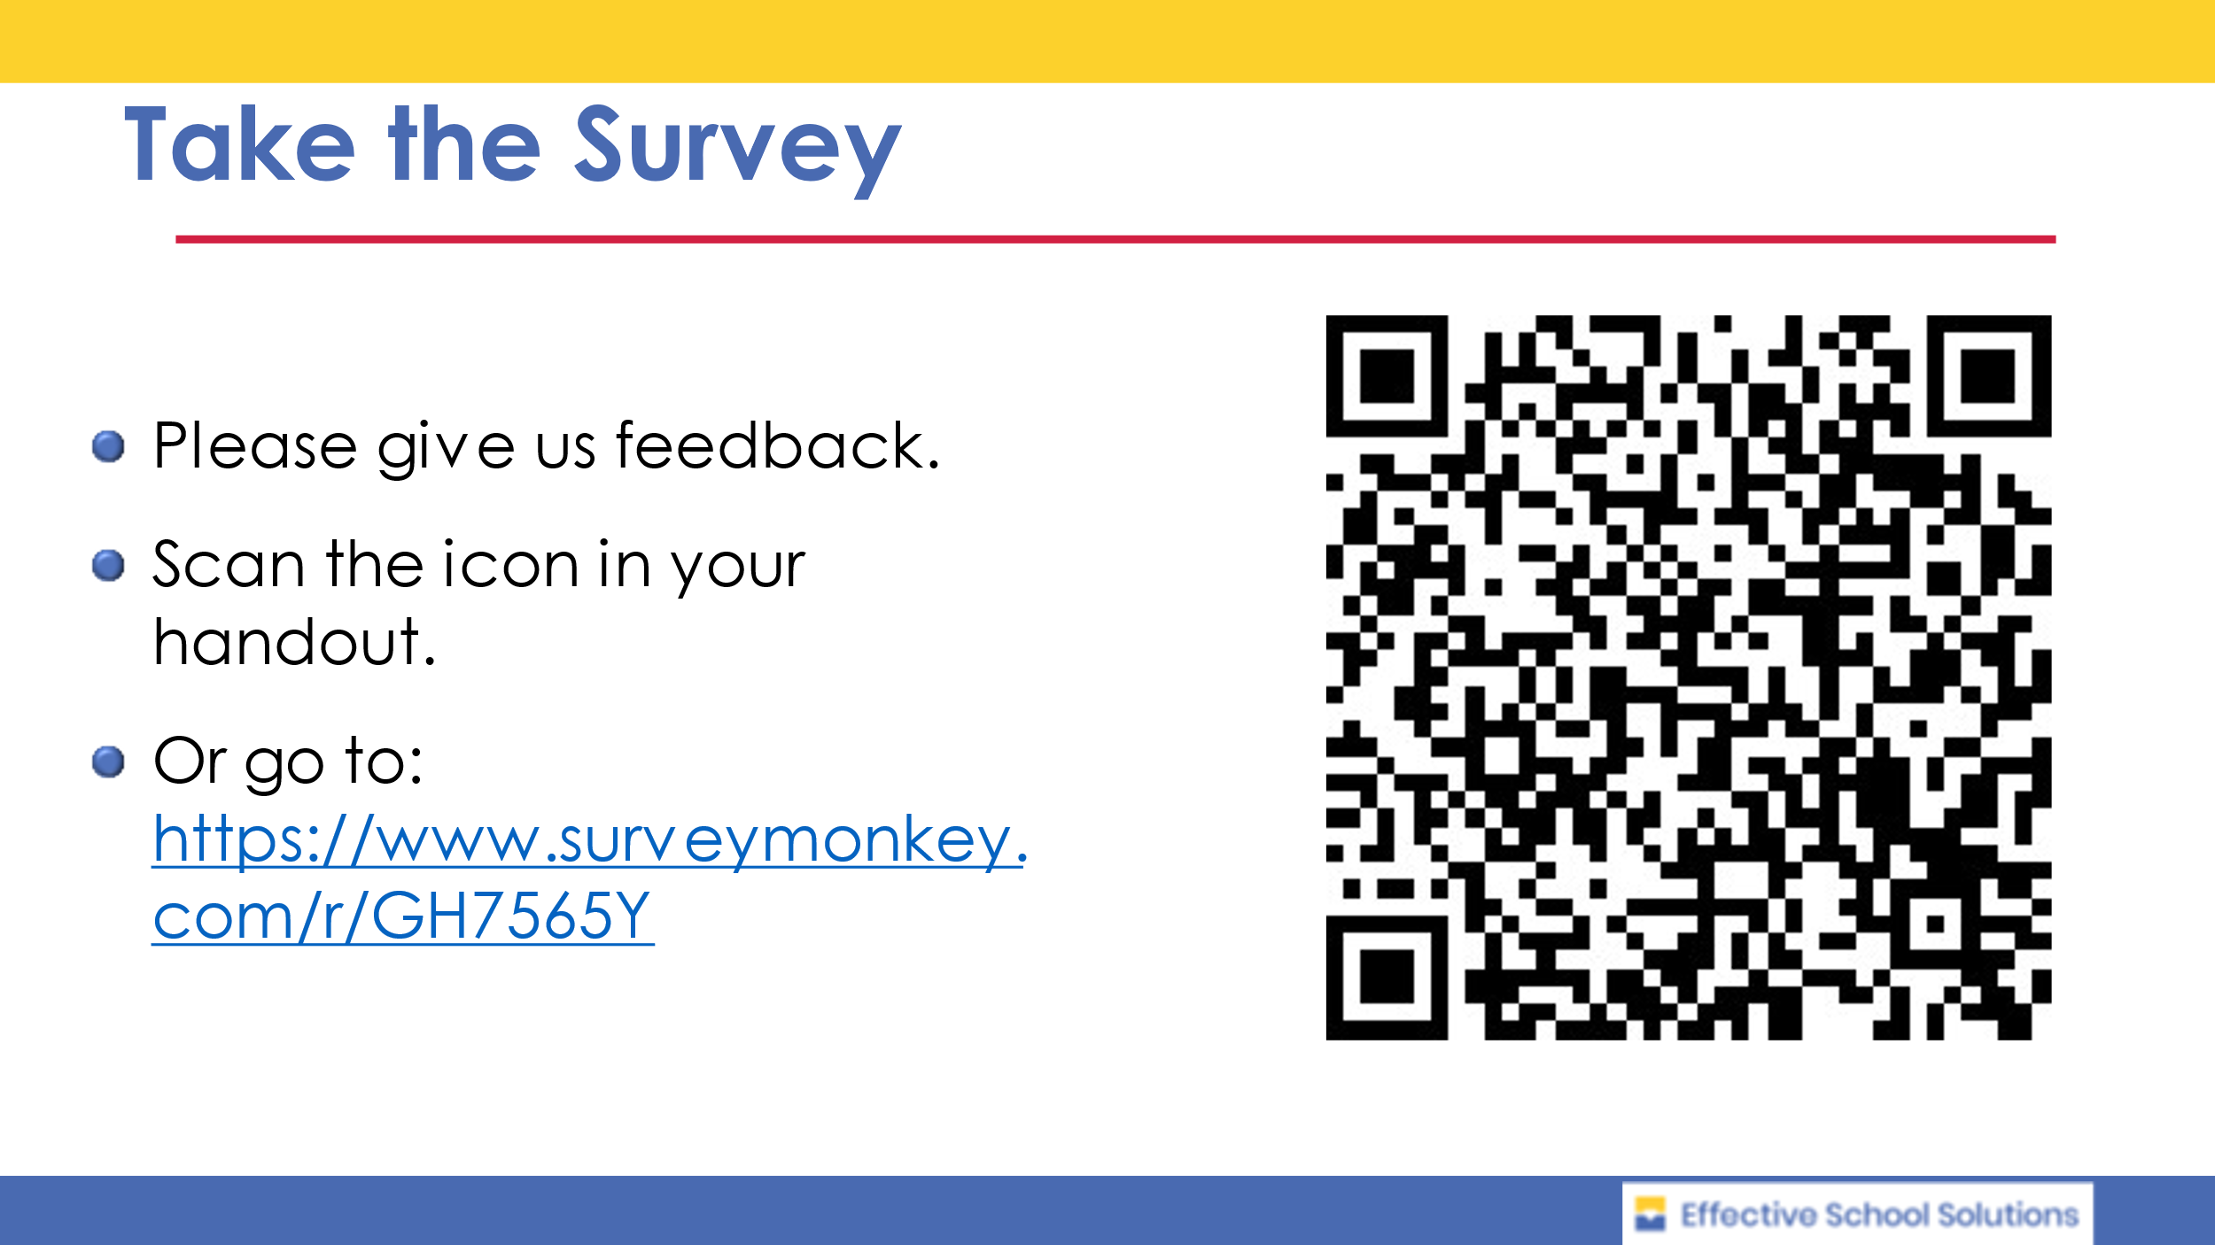

**Resources**

Brundage, Suzanne and Carol Levine, “*The Ripple Effect: National and State Estimates of the U.S. Opioid Epidemic’s Impact on Children.”* 2019, United Hospital Fund of NYC.

Fullilove MT, Fullilove RE, Smith M, et al. *“Violence, trauma, and post-traumatic stress disorder among women drug users.”* Trauma Stress. 1993;6(4):533-543.

Garland EL, Pettus-Davis C, Howard MO. “*Self-medication among traumatized youth: structural equation modeling of pathways between trauma history, substance misuse, and psychological distress.”* J Behav Med. 2013;36(2):175-185.

National Center for Drug Abuse Statistics <https://drugabusestatistics.org/teen-drug-use/>

National Child Traumatic Stress Network <https://www.nctsn.org>

Substance Abuse & Mental Health Services National Hotline: 1-800-662-HELP (4357)

Substance Abuse & Mental Health Services Administration, “A Treatment Improvement Protocol: Trauma-Informed Care in Behavioral Health Services.” Rockville, MD, 2014

Wingo AP, Ressler KJ, Bradley B. “*Resilience characteristics mitigate tendency for harmful alcohol and illicit drug use in adults with a history of childhood abuse: a cross-sectional study of 2024 inner-city men and women.”* J Psychiatr Res. 2014;51:93-99.

|  |
| --- |
|  |