* **Atomic Emission Spectra and Quantum mechanical Model**

**Waves**

**Low Frequency and High Frequency waves**

* Frequency is cycles per second

**Electromagnetic Spectrum**

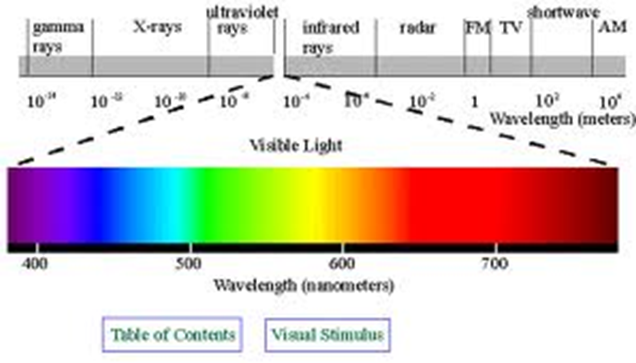

**Atomic Emission Spectra**

* Pattern formed when _________________________________________________________________ grating to separate it into different ____________________________________it contains
* Atomic emission spectra is caused by _____________________________and the electrons move_____________________________________.
* When the energy goes back down to their lower energy level, it __________________________________

**Ground State/Excited State**

* Ground state: electrons at ______________________________________
  + - Example: Sodium’s outer electron is in the s orbital
* Excited state: electrons going to ____________________________________________
  + Example: Sodium outer electron going to the s orbital to p (p orbital is higher energy than s)

**How are frequencies of light emitted by an atom in relation to changes of electron energy?**

* The electrons are moving from a ________________________________________(excited state to ground state)

**Classical vs. Quantum Mechanics**

* Classical mechanics ___________________________________________________
* In quantum mechanics, matter moves _____________and it pertains to______________________________________, such as light particles, atoms

**Heisenberg Uncertainty Principle**

* It is impossible to know both ________________and the __________________electron at the same time

**Famous scientist in quantum**

* ________________________: energy changes in small units known as ____________(Energy= Planck’s constant x frequency) E=hv
  + - * + Planck’s constant is 6.626 x 10-34 Js
* ___________________: used Planck’s theory to explain the photoelectric effect
  + - Photoelectric effect: light can be described as __________________________________________________
* _____________________: explains that all matter moves like waves